Early Education Funding (EEF) Information for parents
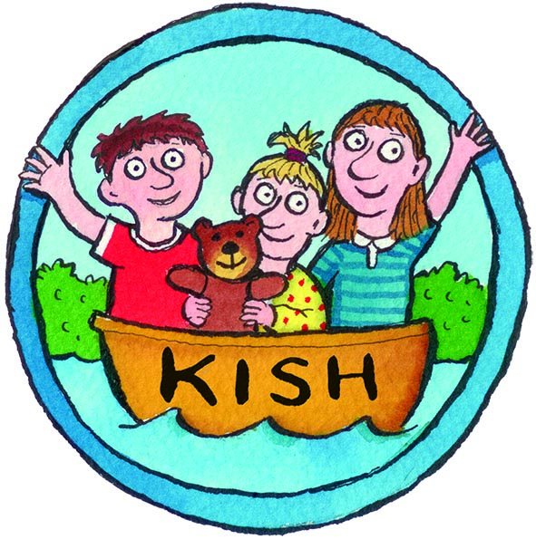
What is the Early Education Funding?
The EEF funds Early Years Education hours for three to four year olds from the term after their third birthday.
The term dates are the same every year and are set by the Government:
1 September – 31 December
1 January – 30 April
1 May– 31 August
What does the grant pay for?
The early years education entitlement is for up to fifteen hours per week, for between 33 and 38 weeks per year.
At KISH Kindergarten this only applies for the morning sessions.
How do I get the money?
In the first tow weeks of each term KISH Kindergarten will carry out a head count of all children who qualify for Early Education funding. KISH Kindergarten will then send the list to the Early Years and Childcare Team and the grant is paid directly to KISH Kindergarten.
Parents need to ensure that when KISH provides the Parent Declaration Form it is signed and returned to Katharina at KISH immediately.
If your child attends another setting, you will not be able to claim the grant for the other setting, as your child will already be receiving free Early years Education at KISH.
What does that mean in regards to my monthly payments?
As now, you will receive an invoice at the beginning of each month for the outstanding hours not paid by the EEF. The first three months of each term the monthly invoice will deduct the Governmental payment. The fourth month of each term the invoice will be for the whole monthly fee.
You are able to use the Childcare Voucher payment for the invoiced amount. Therefore you have to change your Voucher payments form January onwards and adjust them monthly to your invoice. Additionally direct debits are no longer possible because of the different invoice amounts per month. As our company gets charged for every cheque, we do ask you to make monthly bank transfers. If this is not possible please discuss alternatives with Katharina.
KISH Kindergarten is not able to issue invoices for three terms anymore. From January onwards, you will receive invoices monthly.
All invoiced amounts need to be paid by the 10th of every month. If we feel you do not cooperate, KISH Kindergarten Ltd reserves the right to introduce a fee for late payments.

